Opening Rocks & Water RITUAL (adapt as needed for your group)

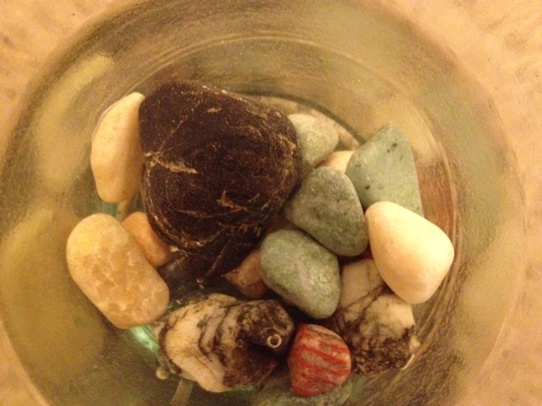
ROCKS/LOWS:

Jesus says, come to me all you who are weary and carrying heavy burdens and I will give you rest....(Matt 11:28)

All of us experience things that feel hard, or heavy, or rough sometimes...like these rocks.

Take a rock in your hands, then close your eyes and take a few deep breaths, noticing what might have felt hard, or rough, or heavy for you this week.

(PAUSE. Option: use bells to mark the silence)

Now one at a time, we’ll gently return our rocks to the bowl. As you place your rock in the bowl, you are invited to share a few words (if you wish) about your burden (or hard thing).

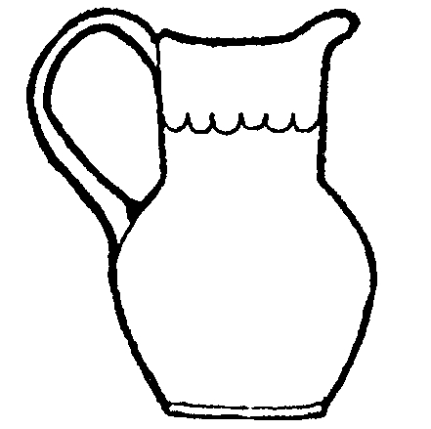
WATER/HIGHS:

Jesus says, let everyone who is thirsty come. Let anyone who wishes take the water of life as a gift...(Rev. 22:17)

This water reminds us that God’s love, and life, and goodness flows over and under and around and even sometimes right out of the hard and rough places in life.

Close your eyes and take a deep breath and notice what has been a gift for you this week. When have you experienced love or energy, joy or blessing?

(PAUSE. Option: use bells to mark the silence)

Now one at a time, we’ll carefully pour a little water over the rocks. As you pour the water, you are invited to share a few words (if you wish) about your blessings (or good things).

