Praying the Parable of the Great Pearl
The Rev. Sylvia Miller-Mutia

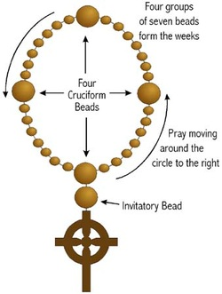
Cross: We pray to God, the One who creates, the One who befriends, the one who inspires; Who holds us close wherever we go, whatever we do, who’s holding us now.

Invitatory: Seek ye first the kingdom of God, and God’s righteousness. And all these things shall be added unto you. Allelu, Alleluia!

Cruciform 1: Remember the merchant who went out in search of the great pearl…

Week 1: Pray for those who are searching; (Searching…)

Cruciform 2: Remember how at last the merchant found the great pearl…how he must have rejoiced!

Week 2: Pray for those who rejoice (Rejoicing…)

Cruciform 3: Remember how the merchant let go of everything he had…
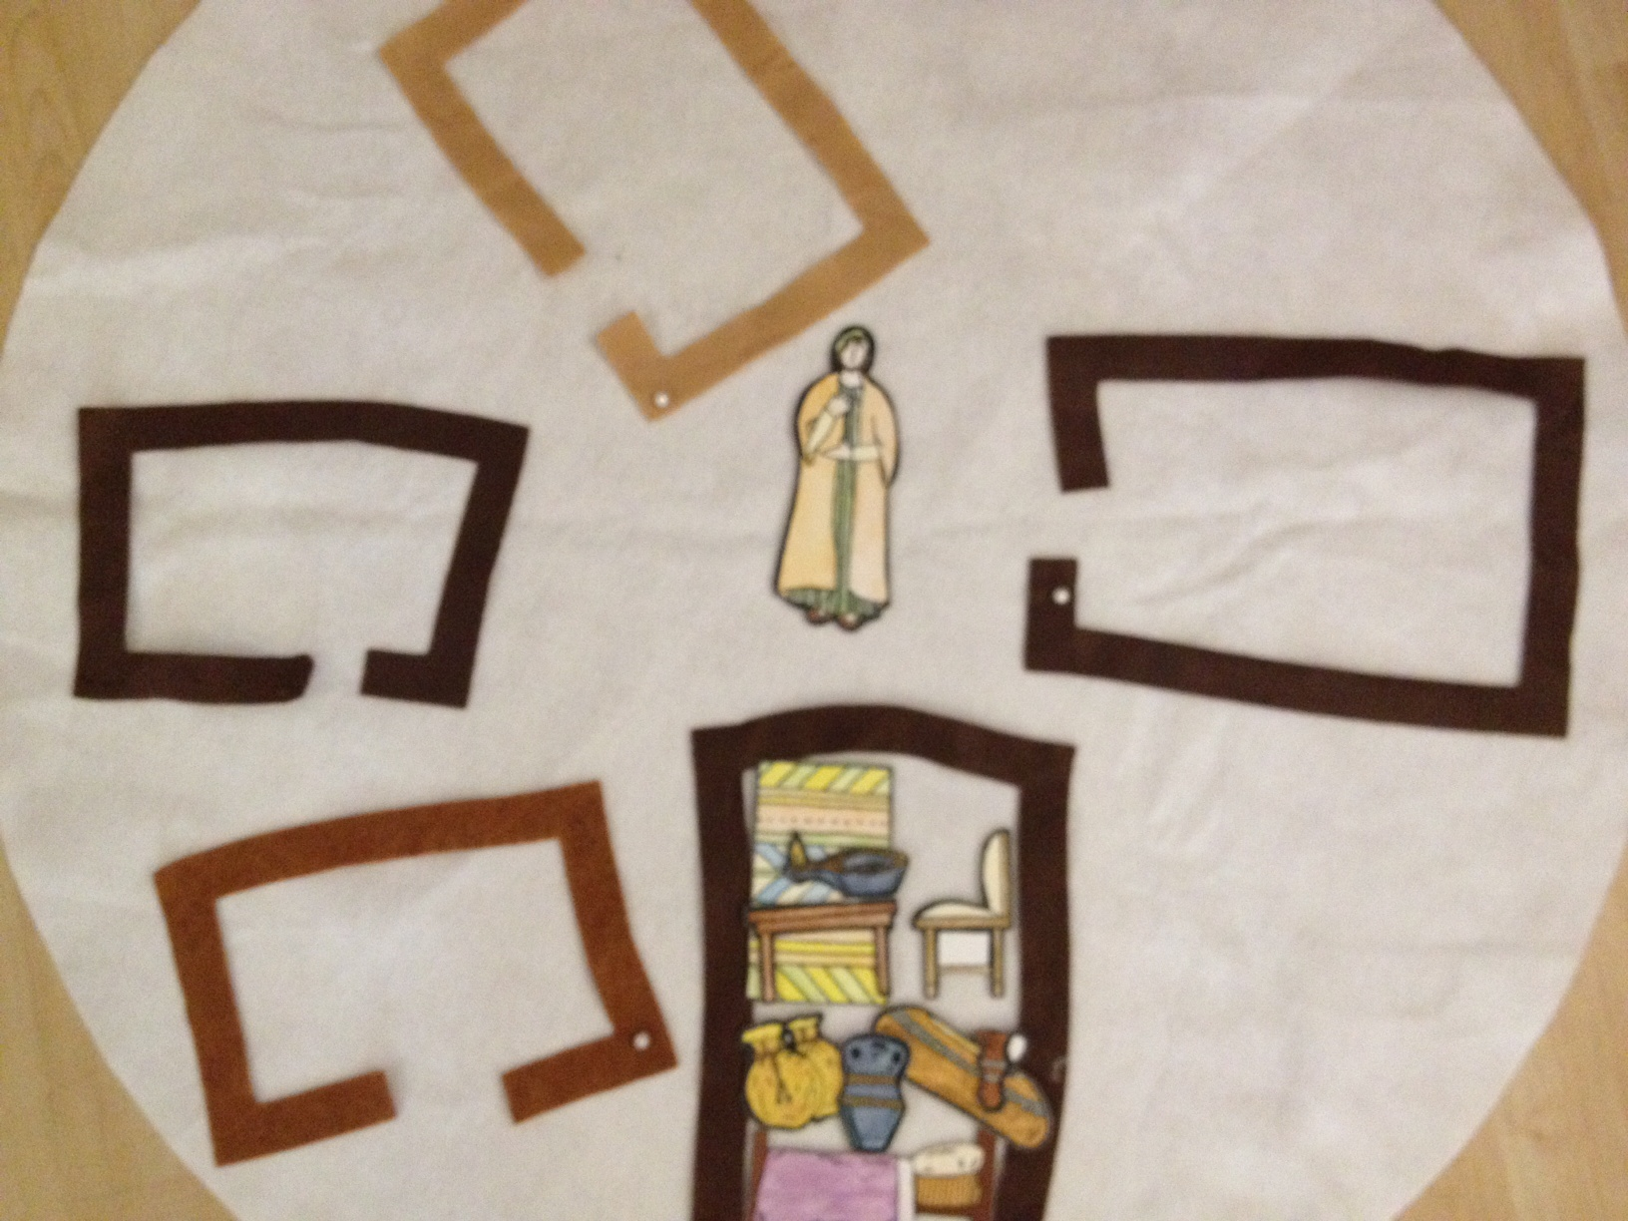
Week 3: Pray for those who are letting go (Letting go…)

Cruciform 4: Remember how the merchant exchanged everything he had for the great pearl

Week 4: Pray that all might discover and treasure what is truly precious in life (Treasure…)

