Godly Play: circle of the church Year, SGN version

(SGN version diverts at the top of pg 28)

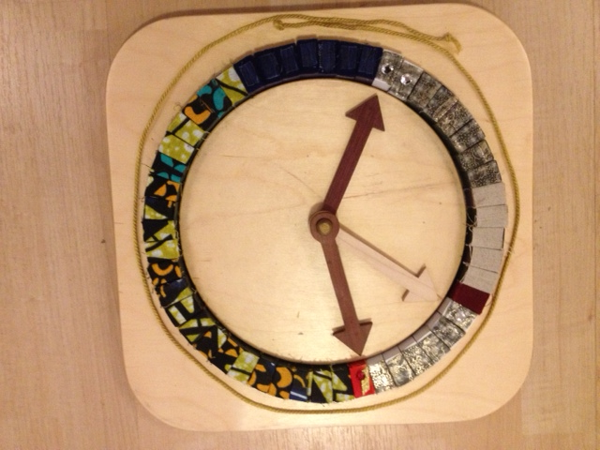
.... Leave the golden cord on the material and begin to remove the blocks. Begin with the "three great times" [ a pair of silver spangled Christmas blocks, a silver spangled Easter block, and a red Pentecost block.] When you pick up the red Pentecost block, drop it briefly: it's so hot! Remember to speak of the three great "times", since Christmas is not always on a Sunday.

Here are the three great times. This is Christmas. This is Eater. This is -- ouch! That's hot! This is Pentecost.

Sit back for a moment and look at the block for the three great times.

People can walk right through these mysteries each year, and not even know what's there. We need time to get ready to come close to these mysteries.

Place the seven blue blocks of Advent in a line to your right of the silver blocks for Christmas. Place the six mud cloth blocks for Lent in a line to your right of the silver block for Easter.

Here are the times for getting ready. The time for getting ready to come close to the mystery of Christmas is called Advent. The time for getting read to come close to the mystery of Eater is called Lent.

Count out five more silver/white Sunday blocks for the season of Easter and place them to your right of the red block for Pentecost.

Easter is such a great mystery that it keeps on going. You can't keep it in one Sunday. It overflows and goes on for six more Sundays. It makes a whole season!

Touch Pentecost again, but snatch your hand away because it's hot.

The season of Easter is also a time for getting ready to come close to the mystery of Pentecost. Ouch It's still hot.

Now only dark-silvery and batik-green blocks are left in the circle. Begin to remove them in groups of three, and place them on the rug in groups of three. Refer to the diagram for the correct placement. Pace yourself. You don't want to rush, but you do want to get the blocks out before the children lose interest.

Here are the weeks between Christmas and Lent.

Here are all of the great, green growing Sundays of the year.

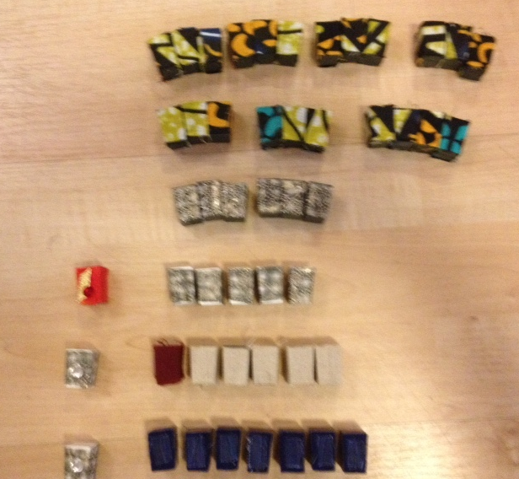

Now let's see if we can build the circle of the year again. Watch carefully, because the church tells time by colors as well as by clocks.

Place the silver blocks for Christmas in the empty circle, then the silver Easter block, and finally the red Pentecost block.

Her are the three great times.

Ouch, it's still hot.

Put the blocks in their approximate final spaces but slide them around to show that those places are not yet set.

Place the seven blue blocks for Advent in front of the silver Christmas blocks. Touch each block in turn as you count "one, two, three, four, five, six, seven."

The time for getting ready for the Mystery of Christmas is called Advent. It is one, two, three, four, five, six, seven weeks long, In other places it is only four weeks, but at St. Gregory's we take seven weeks to get ready. The Church year begins with the beginning of Advent.

Place the linen blocks for Lent in front of the silver Easter block.

Sometimes the color for getting ready for Christmas is purple. That's a serious color, the color of kings. Sometimes the color is blue. Do you know why? Because it is one of the colors for the Mother Mary. Without the Mother Mary, there would be no baby Jesus.

Here at St. Gregory's, we use plain colors to get ready for Easter. The cloth we use upstairs is called mud cloth, and it is simple and serious. Something serious is going to happen to Jesus, the king.

Touch each of the linen Lent blocks in turn as you count "one, two, three, four, five, six."

Look, there are one, two, three, four, five, six weeks for getting ready for Easter. This dark red block is for Palm Sunday, when we sing "Hosanna in the highest."

Place the five silver-over-white blocks for the season of Easter after the block for Easter itself. Touch each of the Easter blocks as you count "one, two, three, four, five, six."

Easter is so great a mystery that you can't keep it in only one Sunday. It keeps on going for one, two, three, four, five, six weeks.

During that time people met Jesus in a new way. He had died on the cross, and that was very sad. But they kept meeting him. Somehow Jesus was still with them, as he is still with us.

Then something wonderful happened. The Apostles went outside of Jerusalem with Jesus in this new way.

Put your two hands over the circle like a blessing. Raise them together about 12 inches.

Then they saw him go up.

Move one hand back down and touch the Pentecost block.

And a few days later, the Holy Spirit came down. The Church was born. The Apostles glowed with the power of the Holy Spirit. Their tongues were like fire when they spoke. They were more alive than they had ever been before That's why the color of Pentecost is red like fire.

Begin to put the green blocks into the circle, three at a time. First place the dark-silvery blocks between the silver Christmas block and the first linen block of Lent.

First we will put some Sundays between Christmas and the beginning of Lent.

Next place the remaining green-batik blocks, three at a time, between the red Pentecost block and the first dark blue block of Advent. Take your time and let the children's year unfold in their imaginations as you replace these great, green growing Sundays.

Here are the rest of the great green growing Sundays. Do you know what the Sundays after Pentecost are called? The are called "the Sundays after Pentecost."

Here is the time when school is out. The summer comes and the days get longer and longer. You can play outside later. People go swimming. Some go to camp. Many go on vacation. The summer comes to an end.

Now you begin to get ready for school. You need new clothes and books. School begins and you often have a new teacher. The days get shorter. School goes on and you get used to all the new things.

Now the days are really short. it gets dark very early. It looks as if the light is just about to go out. Right at that time, when the light seems to be coming to an end, we reach Advent. The year ends, and it begins again. It is time to get ready to enter the mystery of Christmas.

These can be shown by the "clock hands" that extend from the middle of the circle to the Christmas, Easter and Pentecost blocks.

Here are the three great times: Christmas. Easter. Pentecost.

Here are the times for getting ready. Advent. That's seven weeks. Lent. That's six weeks. You can't keep Easter to just one Sunday, so it keeps on going for six weeks. Those weeks are called the season of Easter, too. Here are the great, green growing Sundays of the year.

Move your hand around the reassembled circle.

It's all here. Everything we need. For every beginning, there is an ending, and for every ending there is a beginning. It goes on and on, for ever and ever.

Sit back and enjoy the whole circle of beautiful colors. Now it's time to begin the wondering.

