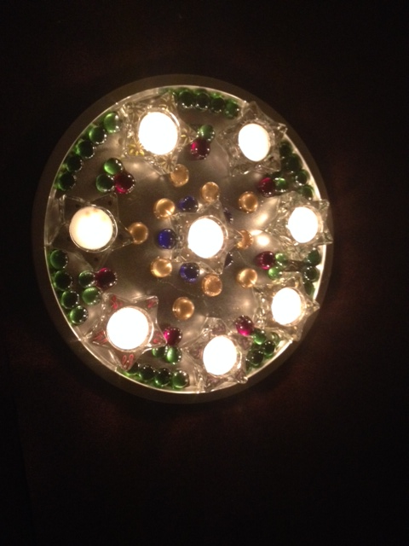
Simple Prayers for
a Seven Week Advent
Listen to the tune for this prayer,
and explore other Advent resources at
http://sgnsource.weebly.com/advent.html

Week 1 (Week of the Sunday on or between Nov 5-12)
Light 1 Advent candle and pray, singing:
O Wisdom, come to us (3x)
come, Wisdom, come

Week 2 (Week of the Sunday on or between Nov 13-19)
Light 2 Advent candles and pray, singing:
O Lord God (or Adonai), come to us (3x)
come, Lord God, come

Week 3 (Week of the Sunday on or between Nov 20-26)
Light 3 Advent candles and pray, singing:
O King of Nations, come to us (3x)
come, King of Nations, come

Week 4 (Week of the Sunday on or between Nov 27-Dec 3)
Light 4 Advent candles and pray, singing:
O Emmanuel, come to us (3x)
come, Emmanuel, come

Week 5 (Week of the Sunday on or between Dec 4-10)
Light 5 Advent candles and pray, singing:
O Root of Jesse, come to us (3x)
come, Root of Jesse, come

Week 6 (Week of the Sunday on or between Dec 11-17)
Light 6 Advent candles and pray, singing:
O Key of David, come to us (3x)
come, Key of David, come

Week 7 (Week of the Sunday on or between Dec 18-24)
Light 7 Advent candles and pray, singing:
O Dayspring, come to us (3x)
come, Dayspring, come

Christmas (Each of the 12 days from Dec 25-January 6)
Light all Advent candles PLUS the Christmas candle (in the center) and pray, singing:
O Christ Child (or Jesus), come to us (3x)
come, Christ Child, come

Find more resources to help you learn, pray, and grow throughout the year at http://sgnsource.weebly.com

