Praying the Parable of the Sower
The Rev. Sylvia Miller-Mutia

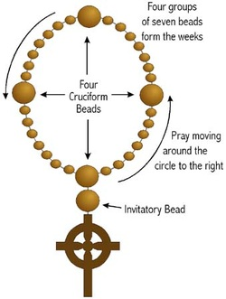
Cross: We pray to God, the One who creates, the One who befriends, the one who inspires; Who holds us close wherever we go, whatever we do, who’s holding us now.

Invitatory: God creates life. Life beholds beauty. Beauty begets love. Love is the life of God.

Cruciform 1: Remember the sower who went out to sow, and some seeds fell along the path and the birds ate the seeds…

Week 1: God, plant your love deep in me. (Deep…)

Cruciform 2: Remember the seeds that fell among stones, and the seeds could not take root, and the sun scorched the plants.

Week 2: God, let your love take root in me (Root…)

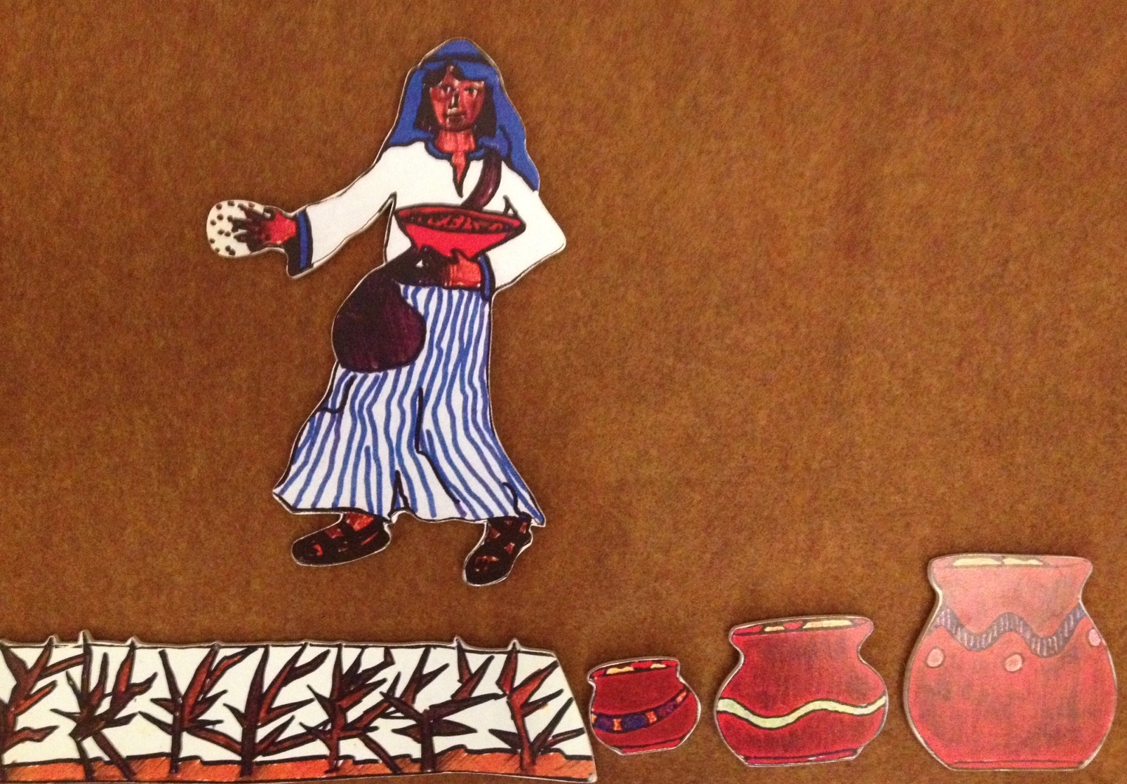
Cruciform 3: Remember the seeds that fell among the thorns, and the thorns choked the plants.

Week 3: God, make space for your love in me (Space…)

Cruciform 4: Remember the seeds that fell on good earth, and the plants grew and grew

Week 4: God let your love grow in me (Grow…)

