Praying the Parable of the Mustard Seed
The Rev. Svlvia Miller-Mutia

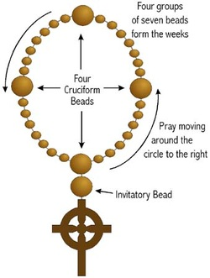
Cross: We pray to God, the One who creates, the One who befriends, the one who inspires; Who holds us close wherever we go, whatever we do, who’s holding us now.

Invitatory: God creates life. Life beholds beauty. Beauty begets love. Love is the life of God.

Cruciform 1: Remember the mustard seed, the tiniest of all seeds

Week 1: God, help me to notice the things that matter, especially the little things (Notice…)

Cruciform 2: Remember the mustard seed being planted in the ground

Week 2: God, help me to trust in your plan and your power (Trust…)

Cruciform 3: Remember the tiny seed growing and growing until it was like a tree
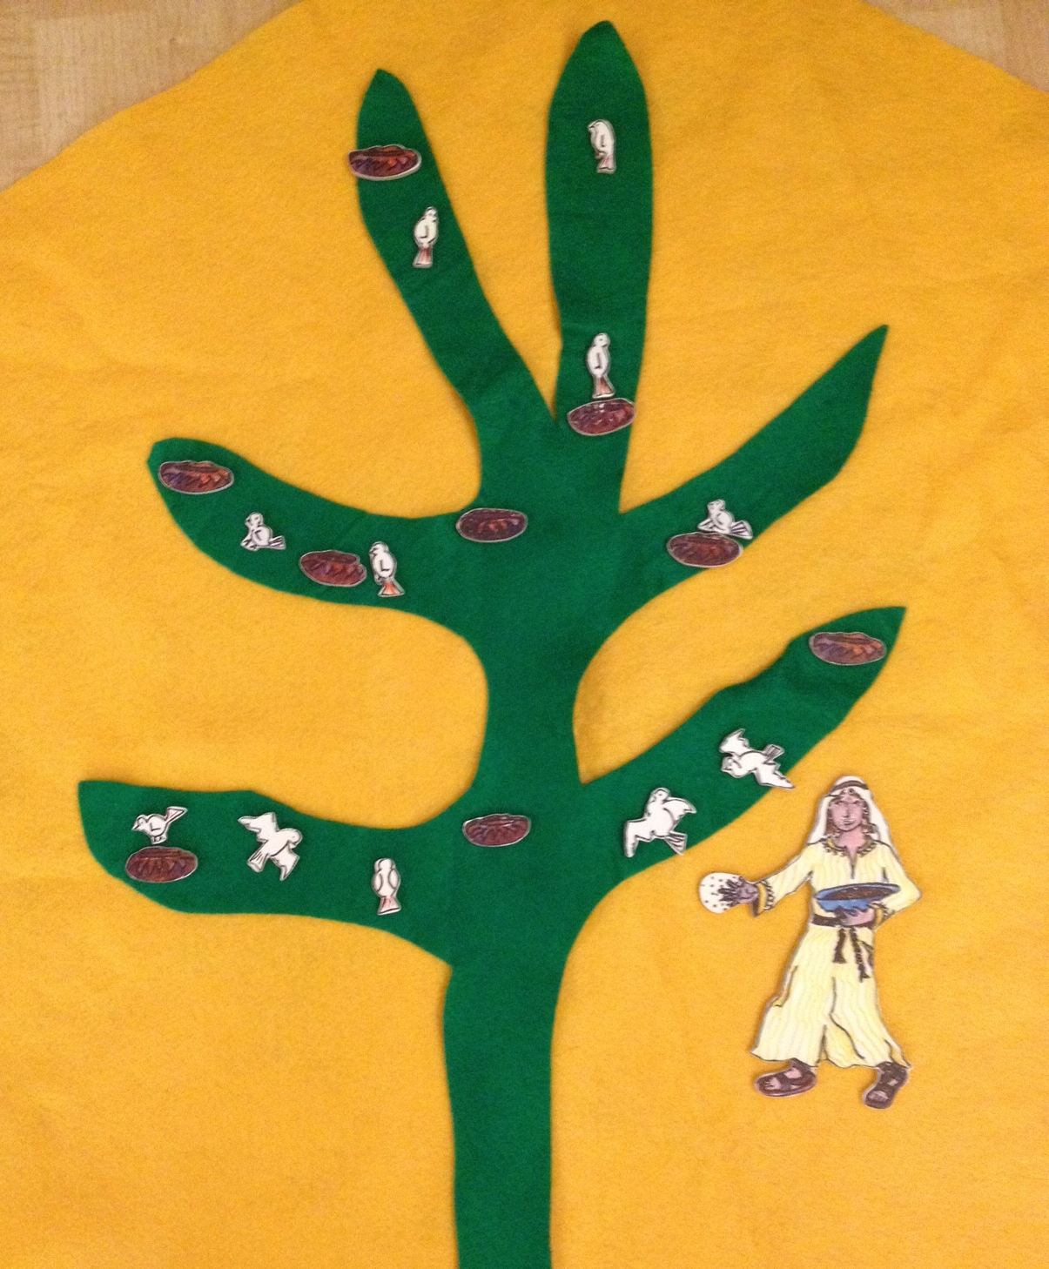
Week 3: God, let your kingdom grow in and through me (Grow…)

Cruciform 4: Remember how the birds of the air came, and made their nests in that tree

Week 4: God help me reach out to others and welcome them (Welcome…)

