Praying the Parable of the Good Shepherd
The Rev. Sylvia Miller-Mutia

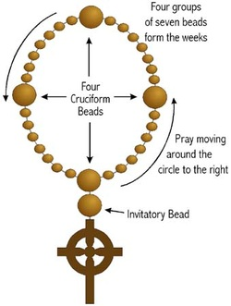
Cross: We pray to God, the One who creates, the One who befriends, the one who inspires; Who holds us close wherever we go, whatever we do, who’s holding us now.

Invitatory: The Lord is my shepherd I’ll walk with him always. (2x) Always, always, I’ll walk with him always. (2x)

Cruciform 1: Remember the Good Shepherd, who shows the way to the good green grass.

Week 1: Pray for the hungry; O God, feed them. (Feed…)

Cruciform 2: Remember the Good Shepherd, who shows the way to the cool, fresh, water.

Week 2: Pray for the thirsty, the tired, the weary; O God, refresh them. (Refresh…)

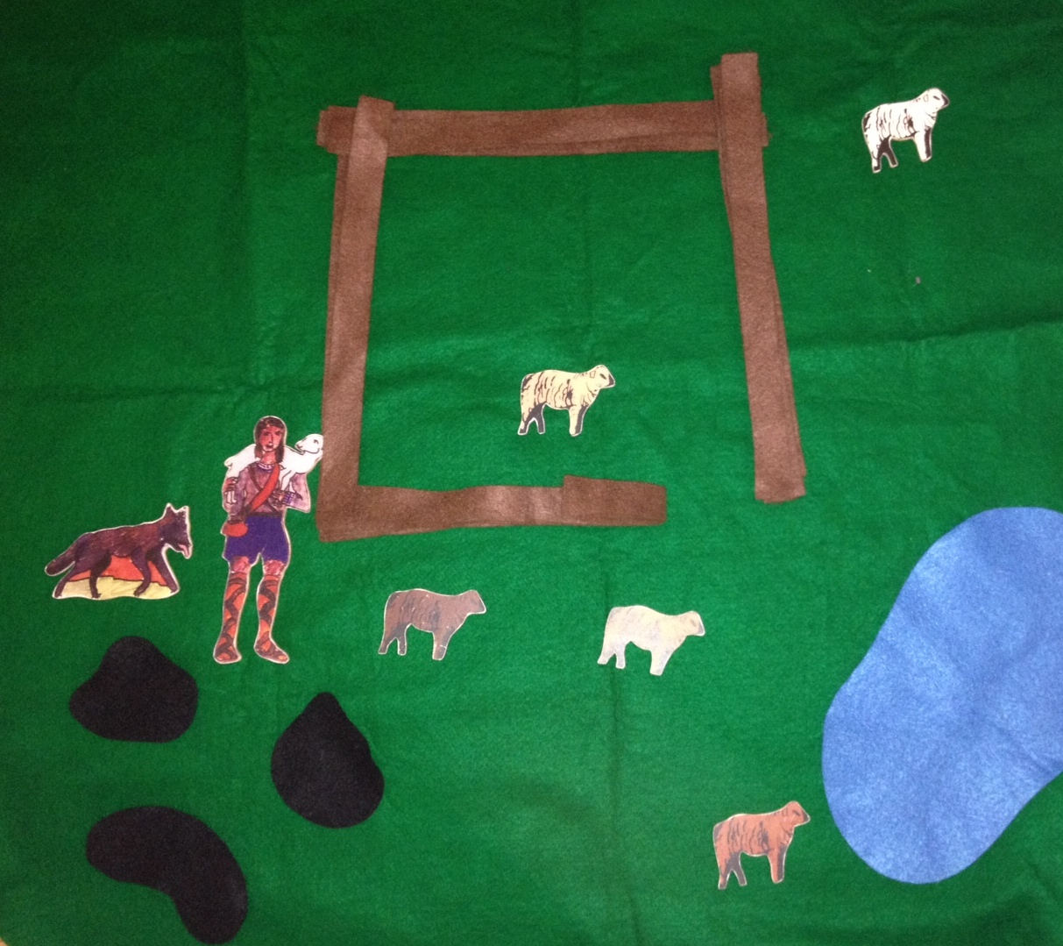
Cruciform 3: Remember the Good Shepherd, who leads the sheep safely through places of danger.

Week 3: Pray for the lost, the afraid, and those in need of guidance; O God, lead them (Lead…)

Cruciform 4: Remember the Good Shepherd, who calls each sheep by name and carries them safely home.

Week 4: Pray for those who have no home; O God, carry them. (Carry…)

