Praying the Parable of the Good Samaritan
The Rev. Sylvia Miller-Mutia

Cross: We pray to God, the One who creates, the One who befriends, the one who inspires; Who holds us close wherever we go, whatever we do, who’s holding us now.

Invitatory: Jesu, Jesu, fill us with your love, show us how to serve the neighbors we have from you.

Cruciform 1: Remember Traveler who was on a journey from Jerusalem to Jericho…

Week 1: God give me strength, wherever I go (Strength…)

Cruciform 2: Remember the Priest who passed by; he might have been scared.

Week 2: God, give me courage when I’m afraid (Courage…)

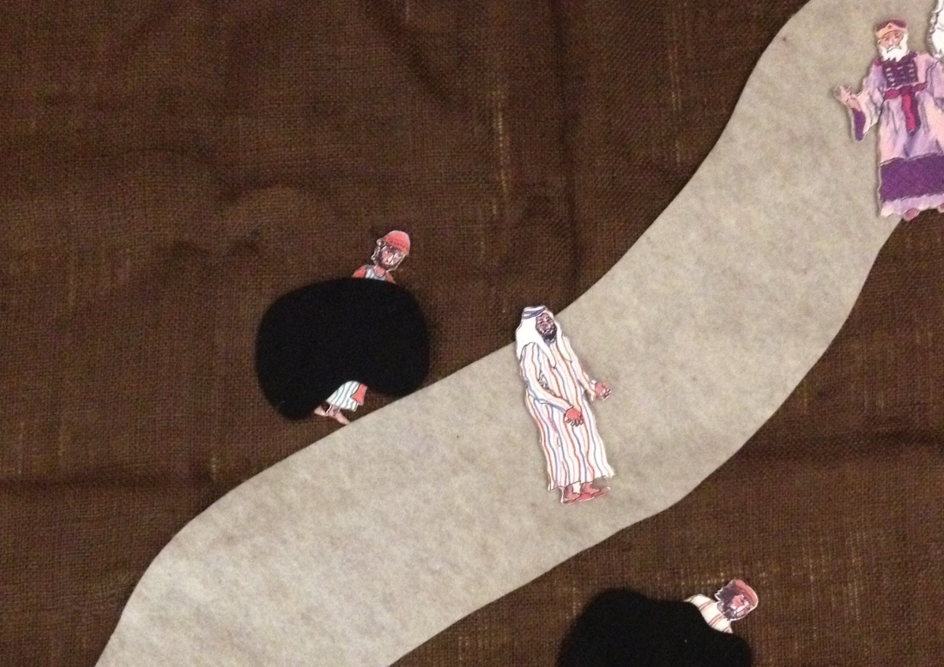
Cruciform 3: Remember the Levite who passed by; he might have been in a hurry

Week 3: God give me patience when I’m in a hurry (Patience…)

Cruciform 4: Remember the Samaritan who helped a stranger in need.

Week 4: God help me love all—strangers and friends (Love…)

